SGPA OF A STUDENT
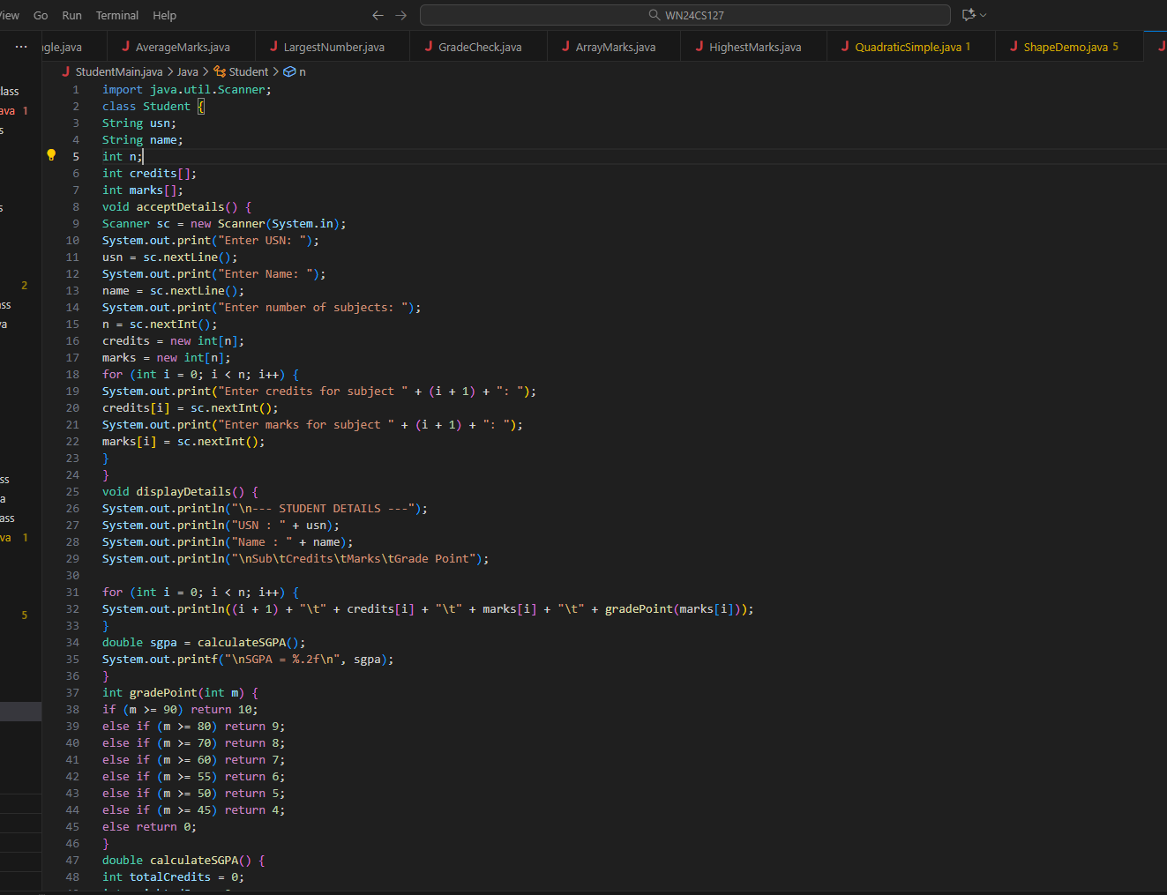
K ABHIRAMA PURANIKA

1WN24CS127

LAB ON:3/11/25

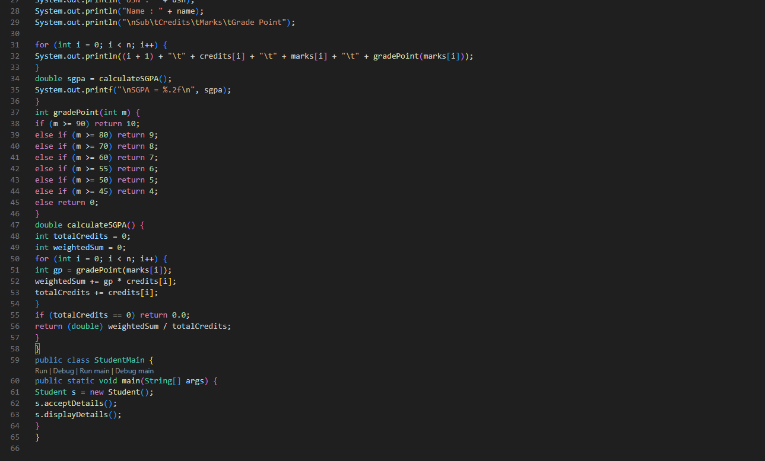
OUTPUT
